Building your brand

Template

Please answer the following questions based on the research you have conducted:

1. Identify three professional people (either that you know personally or in the public domain) and the personal brand attributes you admire about them.

The three persons are:

1. Dr APJ Abdul Kalam
2. Mahendra Singh Dhoni
3. Cristiano Ronaldo

Person One –

The ‘*Missile Man of India*’ or '*People’s President*' was having the following qualities:

* Thirst for knowledge (He was an average student in school but had a strong desire to learn more about the world) and we all know how they done it
* Symbol of Simplicity and high thinking.
* Most Secular at heart- Although he was a Muslim, he used to read both Bhagavad Gita and Quran.
* He was much more than a political figure - He was a scientist, writer, inspirational speaker and motivational personality
* He dedicated every single minute of his life serving the country which is justified by this picture.

Person Two –

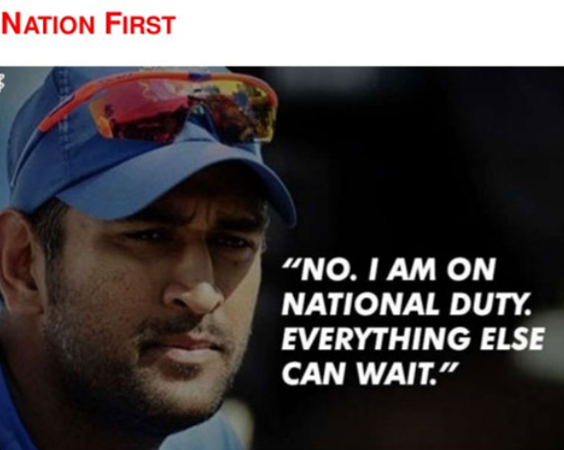

* STAY CALM

No matter what the situation is, MSD is the coolest person you could find on the cricket field. You'll never find him succumb to the pressure and the thing that makes him special is his ability to take rational decisions in tough situations. In our life also, we encounter numerous pressure situations and the only thing that matters is how we react to such situations.

* LEAD FROM FRONT:

On numerous occasions, Mahi single handed won matches for India. He has been amongst the ICC top 10 batsmen in ODIs for past any years and is a tremendous and an extra-ordinary finisher of the game. A team leader should be able to lead by example especially when the team needs the most. No one can forget the inning played by MSD in 2011 World Cup Final at Wankhede, Mumbai. He rose up to the occasion and played decisive role in the victory.

* SHARE THE CREDITS:

You'll never find MSD take the credit for the team's victory. Be it in the interviews, post-match presentations or press conferences, he never boasts about himself, rather he talks about the team effort. This is necessary to bring out confidence in team members, make them feel secure and inspire them to perform.  
Against Australia and later against Pakistan in the finals, he trusted the inexperienced Joginder Singh to bowl the last over! This too was ignoring the tested bowlers he has in the team.

Person Three –

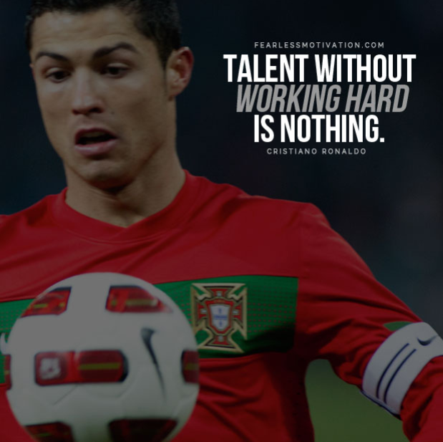

# Confidence

Some call it arrogance, but this unshakeable confidence in his ability means he can take on and beat some of the toughest opponents in the world.

To become one of the greatest, [you must believe](https://www.fearlessmotivation.com/2017/05/16/believe-important-motivational-video/) in your own abilities, you must be willing to back yourself against ANYONE.

Cristiano’s confidence is unmatched, like [many of his records](https://www.sportskeeda.com/football/4-records-by-cristiano-ronaldo-that-will-be-difficult-to-break).

# Desire

Cristiano has never been quiet on his desire to be, and **belief he is** the greatest player in the world.

That desire and belief is a superpower when it comes to competing against some of the toughest opponents in the world.

He uses criticism and negativity as fuel to succeed. You’ll rarely ever see Ronaldo go through a long period without success, he bounces back quickly because his desire to succeed and do something incredible is so strong.

2. From the list of characteristics you admire, identify the personal brand attributes that you want to develop for yourself.

1. Thirst of Knowledge/ Desire to learn new things
2. Power to lead from front.
3. Calmness

3. Identify what actions you need to take to live your identified personal brand attributes.

Working as a leader in my school and also college, I try to take into account their characteristics and work hard to attain them. Some ways I’ve implemented them are:

* I try to keep myself calm in every situation. No matter what kind of mistakes my juniors in college make, I never scold them but actually help them complete the work with them.
* I never stop learning, I try to understand everything I like, and actually there’s lot more for me to understand and learn.
* I try to lead the team always, be it any small thing. I always want to take the front seat and lead the complete team